Project Report on

**IMPLEMENTATION OF SOIL ROUGHNESS INDEX USING INTEL REAL SENSE**

Submitted in partial fulfilment of the requirements for the award of Degree of ENGINEERING

2019-2020



REGIONAL REMOTE SENSING CENTRE (RRSCW)

JODHPUR



M.B.M ENGINEERING COLLEGE

JODHPUR

Guided by:- Submitted by:-

Mr. **Gaurav Kumar** Mr. **Divyanshu Gupta**

Regional Remote Sensing (ELECTRONICS & COMPUTERS)

Centre West (RRSCW) M.B.M Engineering College

JODHPUR Jodhpur

**CERTIFICATE**

This is to certify that the project **“IMPLEMENTATION OF SOIL ROUGHNESS INDEX USING INTEL REAL SENSE”** is the bona fide work carried out by Mr. Abhishek Singh at REGIONAL REMOTE SENSING CENTRE – WEST (RRSCW), JODHPUR during summer training (3 June, 2019 to 18 July, 2019) in partial fulfilment of the requirements for the award of the degree of Bachelor of Engineering as per the norms prescribed by Faculty of Engineering, M.B.M. Engineering College, Jodhpur (JNVU, Jodhpur).

**Mr. Gaurav Sharma**

(Training Coordinator),

**REGIONAL REMOTE SENSING CENTRE - WEST (RRSCW), JODHPUR**

**Names of group members:-**

Mr. Divyanshu Gupta

Mr. Bhavesh Gupta

Mr. Abhishek Singh

Mr. Himanshu Dhawan

**ACKNOWLEDGEMENT**

I take the opportunity to express my heartfelt gratitude to all those people who have provided their immense support and aspect their valuable time in guiding me. It is due to their support, guidance, encouragement and supervision that I have successfully completed summer training project on **“IMPLEMENTATION OF SOIL ROUGHNESS INDEX USING INTEL REAL SENSE”.**

I am highly indebted to my guide **Mr.** **Gaurav Kumar**, Training Coordinator for his guidance and constant supervision as well as for providing necessary information regarding the project.

I would like to articulate my guidance towards the Director, RRSCW Jodhpur, for giving me opportunity to apply theoretical knowledge into practice.

In the end, I would like to extend my sincere thanks to my friends and family members for their support and positive criticisms.

**TABLE OF CONTENTS**

1. Introduction
2. Material and Methods
3. Depth sensor
4. Reference parameter

3. Software Design and Development

1. Hardware Requirement
2. Software Requirement
3. Software Development Life Cycle

4. Software Testing

* Test Performed With Different Sets of Linear Equation

5. Uses and Application

6. Challenges Faced

7. Conclusion

8. Reference

**1. Introduction**

**Abstract** Agricultural soil roughness is pertinent to important agricultural phenomena,

such as evaporation, infiltration or compression. Monitoring roughness variations would

make possible the improvement of tillage operations. In the present work, implementation

of the Microsoft KinectTM RGB-depth camera for dynamic characterization of soil microrelief is proposed and discussed. The metrological performance and the effect of the

operating conditions on three-dimensional reconstruction was analyzed considering both

laboratory tests on calibrated reference surfaces and field tests on different agricultural soil

surfaces. Data set analysis was made on the basis of surface roughness parameters, as

defined by ISO 25178 (2012) series: average roughness, root mean square roughness,

skewness and kurtosis. Correlation between different tillage conditions and roughness

parameters describing soil morphology was finally discussed.

Soil roughness, mainly due to the presence of secondary soil units (such as peds, clods or

aggregates), plays an important role in many agricultural phenomena, such as aggregate

stability, infiltration, runoff, water stored in depressions, erosion, heat flux and evaporation

. These processes are essential for soil conservation, affecting germination and growth of seeds, plant available water and eventually influencing fertility and productivity. On the other hand, soil macro- and micro-topography are continuously and rapidly evolving, due to the combined impact of many factors, such as wind and rainfall erosion, solar heating, vegetation growth and tillage. Large differences in soil roughness are commonly found not only within the same field (macro-roughness), but also locally within a few meters range (micro-roughness).

Monitoring cloddiness and roughness variations would make possible the equipping of

farm machinery for tillage with an electronic feedback or feed-forward system, as depicted

in Fig. 1. In the feed-forward configuration, the system evaluates the state of the soil ahead

of the machine and correspondingly modulates the operation of the working parts, e.g.

forward speed, rotating speed of the rotors, tillage depth, angle of tines, discs or deflectors,

etc. Conversely, in the feed-back configuration, the instrument carries out a real time

analysis on the cloddiness of the soil after machine operations and instantly modifies

working parameters, in order to enhance soil finishing homogeneity or keep the soil

roughness close to a predetermined optimal value. Such an approach is interesting: indeed

taking advantage of the recently introduced ISOBUS communication protocol (ISO 11783-

9:2012) which enables quick and simple data transfer between tractors and implements, it

can allow optimization of operations in terms of:

– machine functioning: the performance can be exploited acting on different parameters

such as forward speed, mechanical parts positions, pto speed, etc.;

– seedbed preparation: to obtain an optimal aggregate size distribution, with ideally no

variations due to differences in soil texture, headlands, etc.;

– time: the feedback system slows up the operation only when reference parameters

exceed given thresholds;

– investments: reduced working time leads to reduction of fuel consumption and wear of

mechanical parts;

– pollution: avoiding excessive soil pulverization and minimizing power overuse, release

of pollutants in the atmosphere can be limited;



Fig. 1 Schematic representation of a three-dimensional sensor unit, positioned in front of the tractor for a

feed-forward loop or alternatively behind the tractor for a feed-back system

To allow such a ‘‘dynamic calibration’’ approach, instruments are needed for fast threedimensional characterization of soil roughness. To this end, contact instruments cannot be applied due to their typically slow sampling rate. On the other hand, several non-contact

Fig. 1 Schematic representation of a three-dimensional sensor unit, positioned in front of the tractor for a feed-forward loop or alternatively behind the tractor for a feed-back system

approaches potentially suitable for fast soil sensing have been proposed in the past and in recent years , mainly based on image analysis techniques, laser scanning and photogrammetry. However suchtechniques suffer from various impediments. Image analysis is not suitable in the case of geometric clod features and may need human intervention for proper segmentation execution . Laser scanning is a very interesting choice thanks to resolution and fast sampling performances. However, it is better suited to a single profile rather than for whole area analyses and, as costs are still relatively high, it is difficult to justify its implementation in agricultural machines . Photogrammetry is also an interesting solution, benefitting from low cost sensors. However, computational time for 3D reconstruction is still an issue.

However, in recent years the advent of faster computer processors is pushing the introduction

of new inexpensive sensors, which make the possibility of integration with

agricultural machines more realistic.

In the present work, a suitable low-cost sensor based on 3D depth camera technology

for dynamic characterization of soil micro-relief is proposed, discussing possibilities and

limitations for agricultural applications. The main objectives were to (1) study the performance of the camera under controlled conditions in the laboratory, and (2) study if

differences in soil micro-relief due to tillage could be determined under field conditions.

**2. Material and Method**

**Depth sensing camera technology**

The present work takes advantage of depth sensing camera technologies. Such technology

is not a new invention but, in the last couple of years, it has raised great interest and

widespread diffusion mainly thanks to recent applications in the video games industries. As

a consequence, this technology has rapidly reached a mature level and low-cost depth

cameras are currently available on the market.

For the present study, a INTEL REAL SENSE RGB-depth camera was implemented, which is already raising significant interest and growing attention for agricultural applications because of its high quality and low cost. This sensor includes an infrared laser emitter, an infrared camera and an RGB camera. Depth information is achieved through a triangulation process: a diffraction grating splits the infrared laser into a given pattern which is projected onto the scene. The pattern is collected by the infrared camera and compared with the projected one: local shifts generate a disparity map, where larger shift values correspond to positions further from the sensor and, conversely, lower values correspond to positions closer to the sensor.

Figure 2 show the image of intel real sense.

.

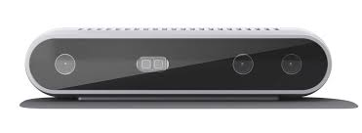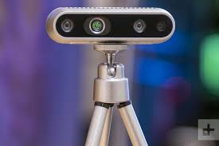

Fig . 2 intel real sense camera

**Reference parameters**

The real sense sensor allows depth data transfer to a PC or notebook using a USB cable via a USB port. The signal can then be processed taking advantage of different open libraries which are accessible mainly on platforms: Real Sense SDK (the Software Development Kit allowing user to code and run specific analysis tools). The latter platform was the one implemented to allow processing of collected data and calculation of reference parameters. In particular for the present work, as a reference for the tests, four parameters were chosen, namely Sa, Sq, Ssk and Sku, as defined by standard ISO 25178-2 (2012).

Sa is the arithmetical mean height of the ordinate values within a definition area A, and

is defined by (1):

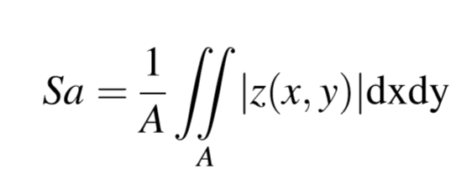

where x, y are the co-ordinates in the horizontal axis and z the ordinate in the vertical axis.

Sq is the root mean square value of the ordinate values, and is defined by (2):

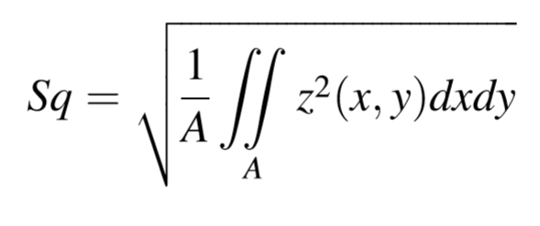

Ssk is the skewness of the scale-limited surface and is quantified by the quotient of the

mean cube value of the ordinate values and the cube of the root mean square roughness

Sq:

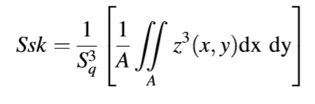

Sku is the kurtosis of the scale-limited surface and is defined as the quotient of the mean

Quadratic value of the ordinate values and the fourth power of the root mean square roughness Sq:

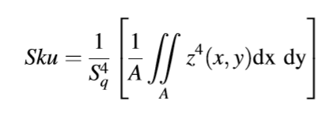

Such parameters not only quantify the main amplitude of surface roughness distribution

(Sa and Sq), but also the level of asymmetry (Ssk) and peakedness (Sku) of the distribution

itself about its mean. Taken together, such parameters can describe in a comprehensive

way, the different aspects of soil condition

**3. Software Design and Development**

**3.1. Hardware Requirements**Processor: Intel® Core™ i5-8250U CPU @ 1.60 GHz to 1.80 GHz  
Installed RAM: 8.00 GB  
System Type: 64-bit Operating System

**3.2. Software Requirements**Operating System: Windows 10  
Editor : PYCHARM

**3.3. Software Development Life Cycle (SDLC)**It is a well-defined, structured sequence of stages in software engineering to develop the intended software product.

The waterfall model was the first process model to be introduced. It is also referred to as a linear-sequential life cycle model. It is very simple to understand and use. In a waterfall model, each phase must be completed before the next phase can begin and there is no overlapping in the phases.

The waterfall model illustrates the software development process in a linear sequential flow. This means that any phase in the development process begins only if the previous phase is complete. In this waterfall model, the phases do not overlap.

**Waterfall Model – Design**

Waterfall approach was first SDLC model to be used widely in Software Engineering to ensure success of the project. In “The Waterfall” approach, the whole process of software development is divided into separate phases. In this waterfall model, typically, the outcome of one phase acts as the input for the next phase sequentially.

The following illustration is a representation of the different phases of the waterfall model.

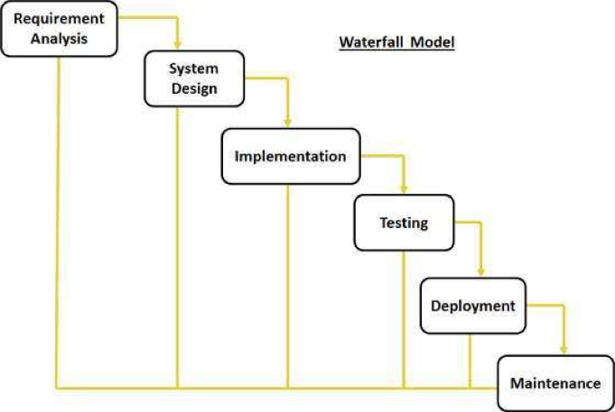

**Requirement gathering and analysis** – All possible requirements of the system to be developed are captured in this phase and documented in a requirement specification document.

**System Design** – The requirement specifications from first phase are studied in this phase and the system design is prepared. This system design helps in specifying hardware and system requirements and helps in defining the overall system architecture.

**Implementation** – With inputs from the system design, the system is first developed in small programs called units, which are integrated in the next phase. Each unit is developed and tested for its functionality, which is referred to as Unit Testing.

**Integration and Testing** – All the units developed in the implementation phase are integrated into a system after testing of each unit. Post integration the entire system is tested for any faults and failures.

**Deployment of system** – Once the functional and non-functional testing is done; the product is deployed in the customer environment or released into the market.

**Maintenance** – There are some issues which come up in the client environment. To fix those issues, patches are released. Also to enhance the product some better versions are released. Maintenance is done to deliver these changes in the customer environment.

All these phases are cascaded to each other in which progress is seen as flowing steadily downwards (like a waterfall) through the phases.

The next phases is started only after the defined set of goals are achieved for previous phase and it is signed off, so the name “Waterfall Model”. In this model, phases do not overlap.

**Application** – Every software developed is different and requires a suitable SDLC approach to be followed based on the internal and external factors. Some situations where the use of waterfall model is most appropriate are –  
 **·** Requirements are very well documented, clear and fixed  
 **·** Product definition is stable.  
 **·** Technology is understood and is not dynamic.  
 **·** There are no ambiguous requirements.  
 **·** Ample resources with required expertise are there to support the product.  
 **·** The product is short.

**4. Software Testing**

Software testing is an investigation conducted to provide stakeholders with information about the quality of the software product or service under test. Software testing can also provide an objective, independent view of the software to allow the business to appreciate and understand the risks of software implementation. Test techniques include the process of executing a program or application with the intent of finding software bugs (errors or other defects), and verifying that the software product is fit for use.

As per the tasks given to me during my part of a summer trainee, I was assigned with the task to develop a software that could solve linear equation using Kaczmarz method.

**Types of Testing**

**Alpha testing**

Alpha testing is simulated or actual operational testing by potential users/customers or an independent test team at the developers' site. Alpha testing is often employed for off-the-shelf software as a form of internal acceptance testing before the software goes to beta testing.

**Beta testing**

Beta testing comes after alpha testing and can be considered a form of external user acceptance testing. Versions of the software, known as beta versions, are released to a limited audience outside of the programming team known as beta testers. The software is released to groups of people so that further testing can ensure the product has few faults or bugs. Beta versions can be made available to the open public to increase the feedback field to a maximal number of future users and to deliver value earlier, for an extended or even indefinite period of time (perpetual beta).

**Testing Levels**

**Unit testing**

Unit testing refers to tests that verify the functionality of a specific section of code, usually at the function level. In an object-oriented environment, this is usually at the class level, and the minimal unit tests include the constructors and destructors.

Developers usually write these types of tests as they work on code (white-box style), to ensure that the specific function is working as expected. One function might have multiple tests, to catch corner cases or other branches in the code. Unit testing alone cannot verify the functionality of a piece of software, but rather is used to ensure that the building blocks of the software work independently from each other.

Unit testing is a software development process that involves a synchronized application of a broad spectrum of defect prevention and detection strategies in order to reduce software development risks, time, and costs. The software developer or engineer performs it during the construction phase of the software development life cycle. Unit testing aims to eliminate construction errors before code is promoted to additional testing; this strategy is intended to increase the quality of the resulting software as well as the efficiency of the overall development process.

Depending on the organization's expectations for software development, unit testing might include static code analysis, data-flow analysis, metrics analysis, peer code reviews, code coverage analysis and other software testing practices.

**Integration testing**

Integration testing is any type of software testing that seeks to verify the interfaces between components against a software design. Software components may be integrated in an iterative way or all together ("big bang"). Normally the former is considered a better practice since it allows interface issues to be located more quickly and fixed.

Integration testing works to expose defects in the interfaces and interaction between integrated components (modules). Progressively larger groups of tested software components corresponding to elements of the architectural design are integrated and tested until the software works as a system.

The code used for the given project in determining the soil roughness parameter is as follows :

# First import the library

import pyrealsense2 as rs

import numpy as np

import cv2

import math

pipeline = rs.pipeline()

config = rs.config()

config.enable_stream(rs.stream.depth, 1280, 720, rs.format.z16, 30)

config.enable_stream(rs.stream.color, 1280, 720, rs.format.bgr8, 30)

pipeline.start(config)

try:

# Create a context object. This object owns the handles to all connected realsense devices

sum=0.0

sum1=0.0

sum2=0.0

sum3=0.0

area=480*640

i=0

while (i<1):

# This call waits until a new coherent set of frames is available on a device

# Calls to get_frame_data(...) and get_frame_timestamp(...) on a device will return stable values until wait_for_frames(...) is called

frames = pipeline.wait_for_frames()

i=i+1

depth = frames.get_depth_frame()

color_frame = frames.get_color_frame()

if not depth: continue

# Print a simple text-based representation of the image, by breaking it into 10x20 pixel regions and approximating the coverage of pixels within one meter

# coverage = [0] * 64

depth_image = np.asanyarray(depth.get_data())

color_image = np.asanyarray(color_frame.get_data())

depth_colormap = cv2.applyColorMap(cv2.convertScaleAbs(depth_image, alpha=0.03), cv2.COLORMAP_JET)

# Stack both images horizontally

images = np.hstack((color_image, depth_colormap))

cv2.namedWindow('RealSense', cv2.WINDOW_AUTOSIZE)

cv2.imshow('RealSense', images)

cv2.waitKey(8000)

# Show images

for y in range(480):

for x in range(640):

dist = depth.get_distance(x, y)

sum +=dist

sum1+=(dist*dist)

sum2 +=(dist*dist*dist)

sum3 += (dist*dist*dist*dist)

Sa=sum/area

Sq=math.sqrt(sum1/area)

Ssk=(sum2/area)/(Sq*Sq*Sq)

Sku=(sum3/area)/(Sq*Sq*Sq*Sq)

print("Sa = ",Sa)

print("Sq = ",Sq)

print("Ssk = ",Ssk)

print("Sku = " ,Sku)

#finally:

#pipeline.stop()

exit(0)

# except rs.error as e:

# # Method calls agaisnt librealsense objects may throw exceptions of type pylibrs.error

# print("pylibrs.error was thrown when calling %s(%s):\n", % (e.get_failed_function(), e.get_failed_args()))

# print(" %s\n", e.what())

# exit(1)

except Exception as e:

print(e)

pass

The screenshot of code and program out for various inputs is shown below:

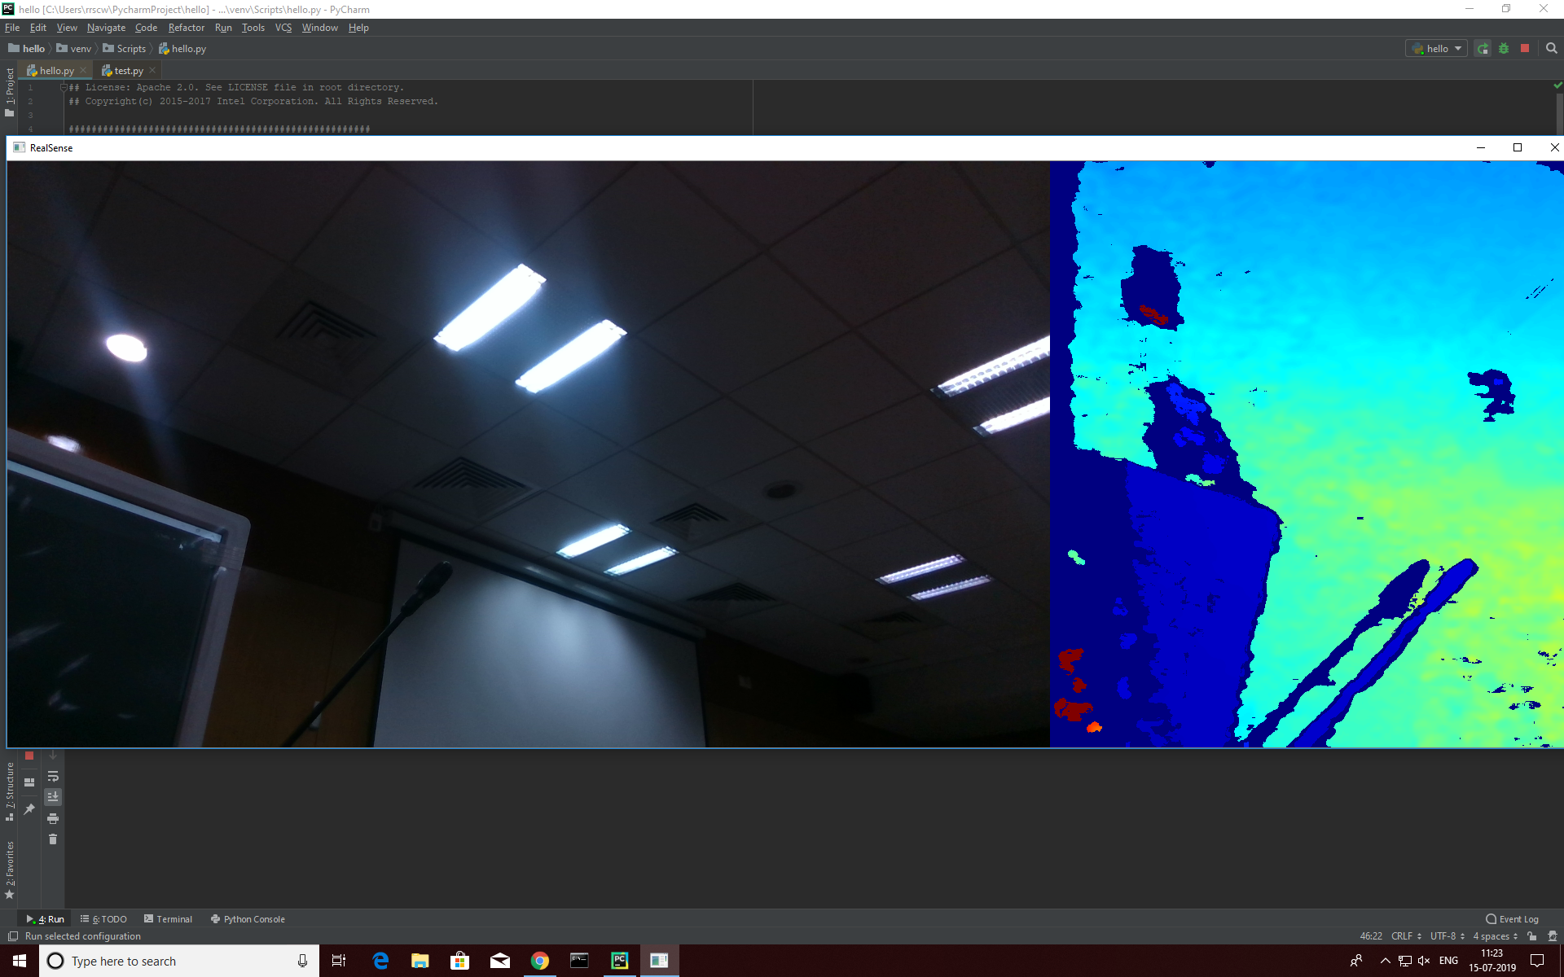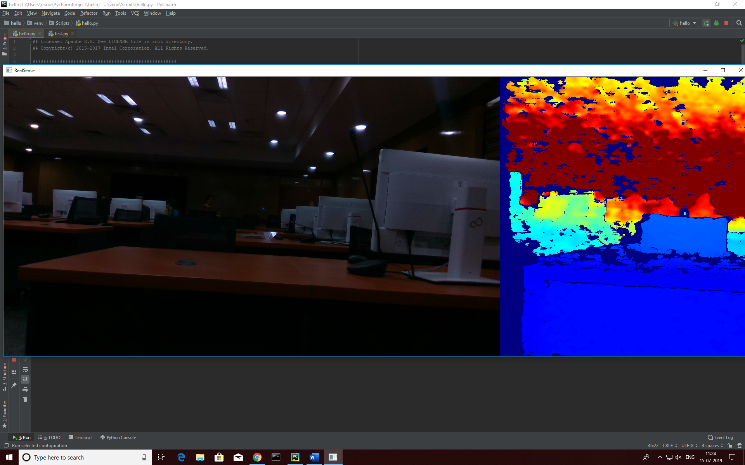

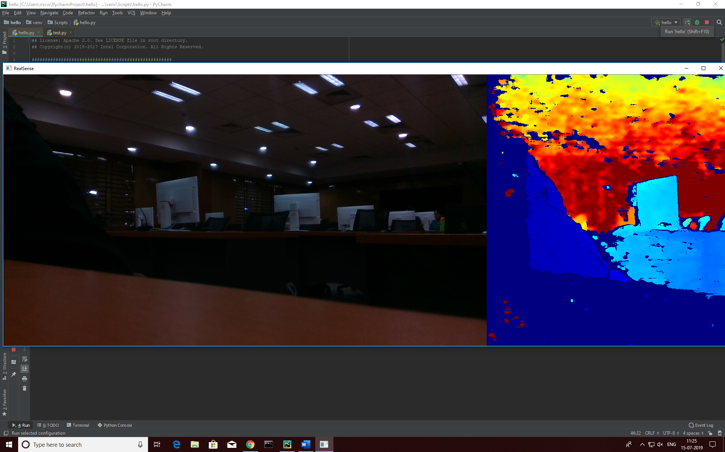

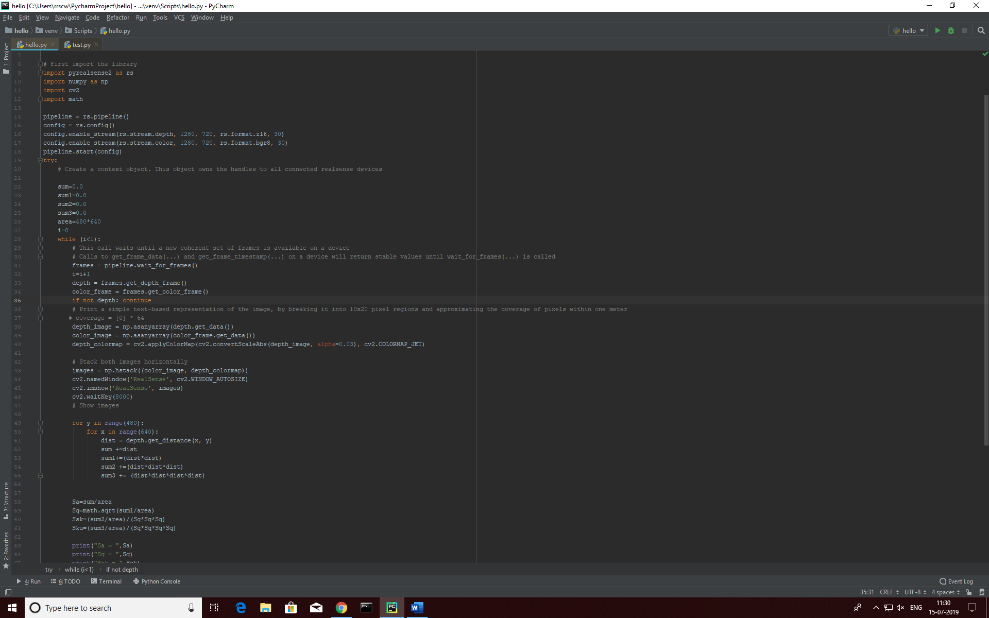 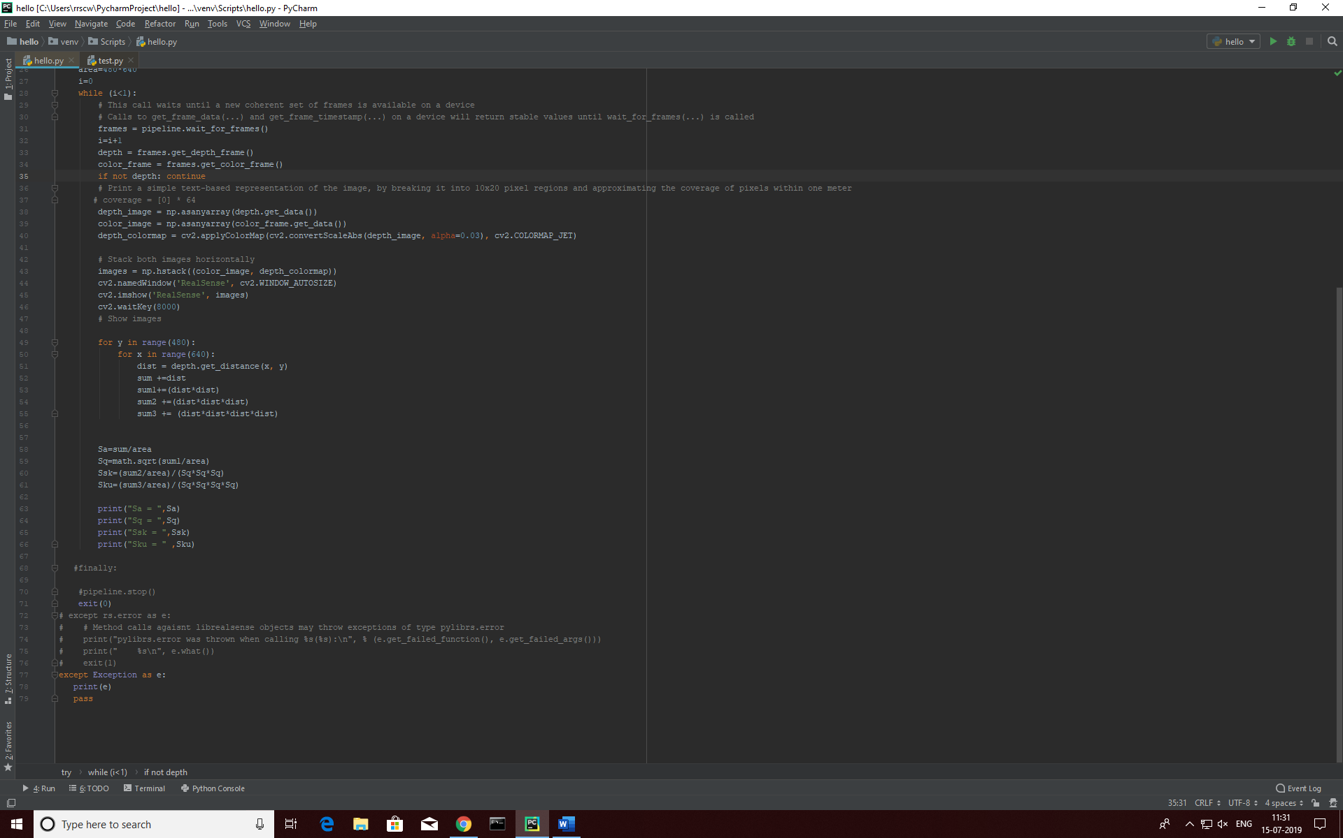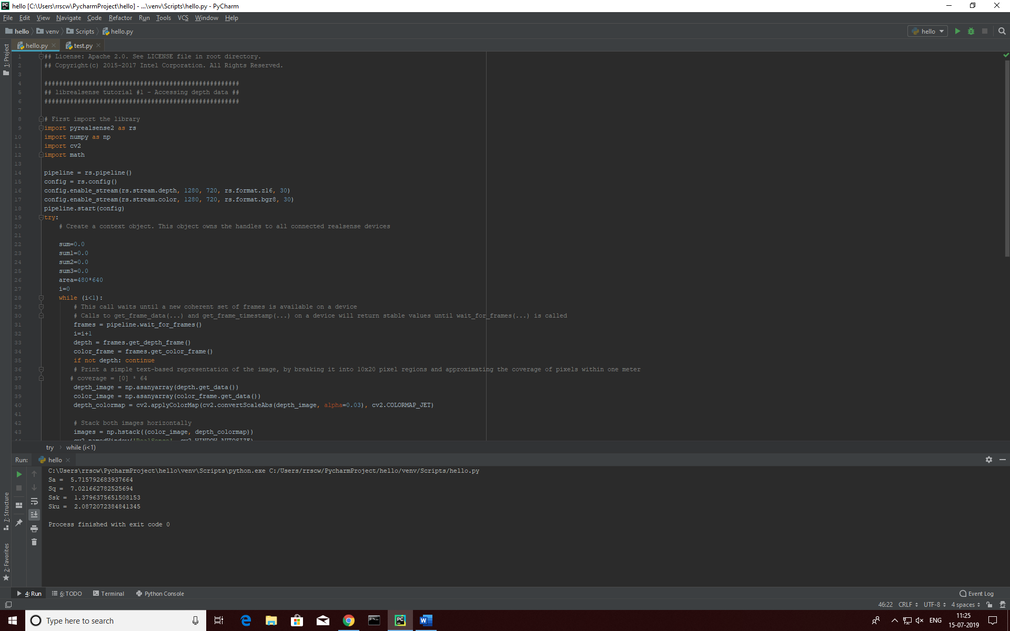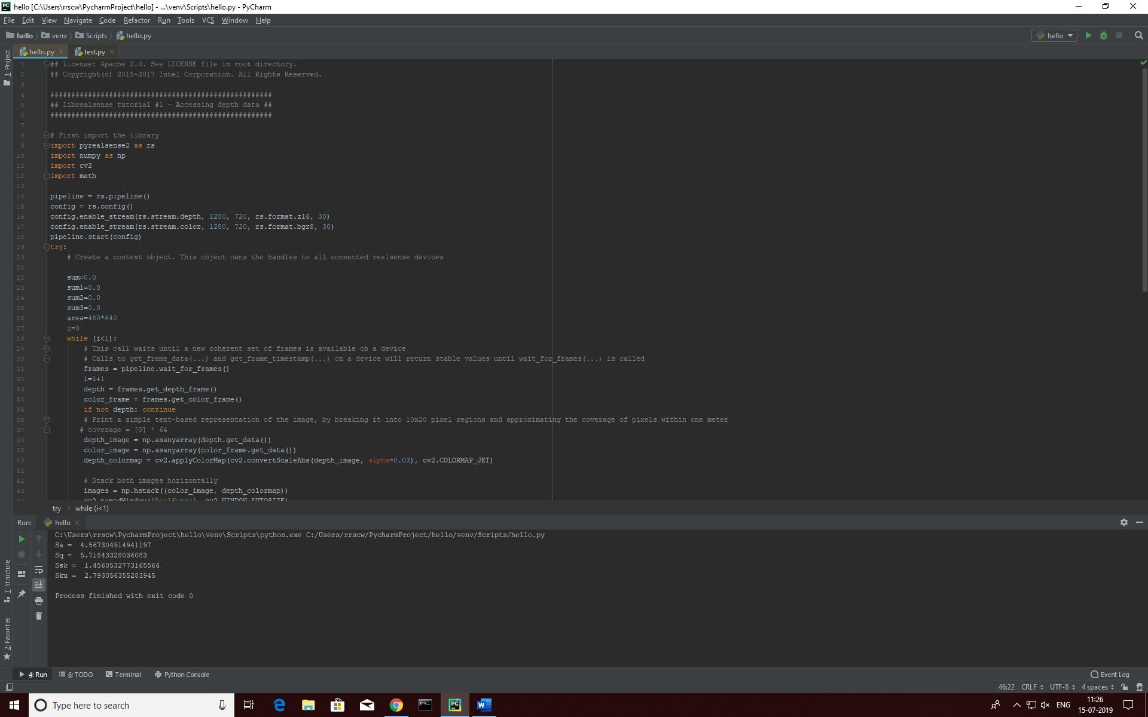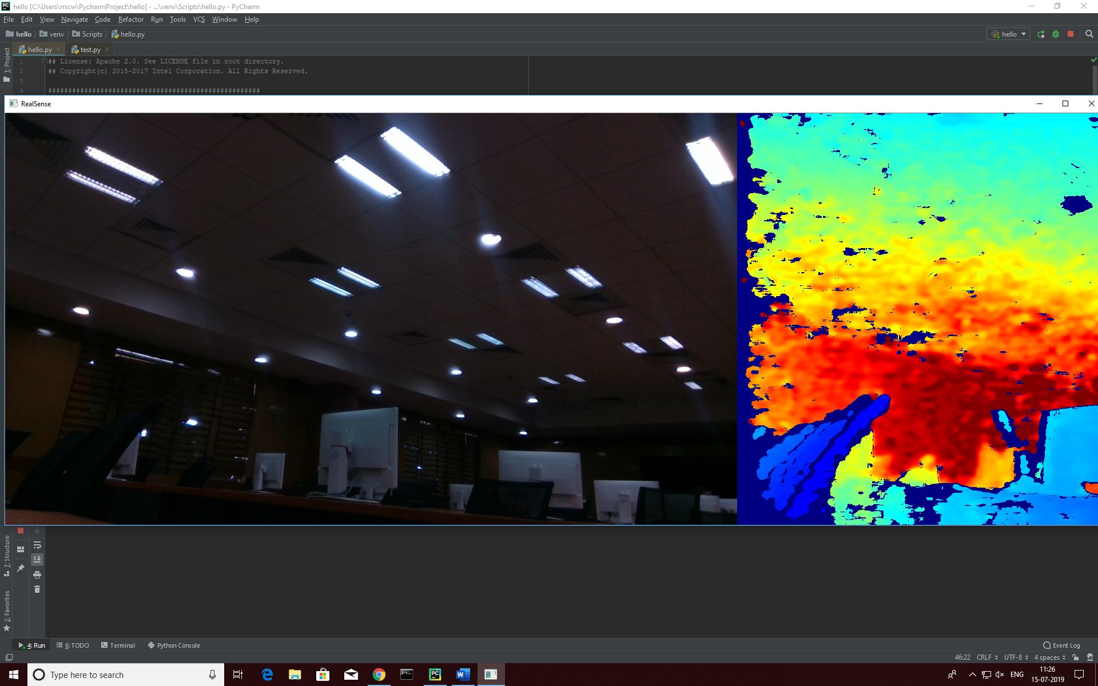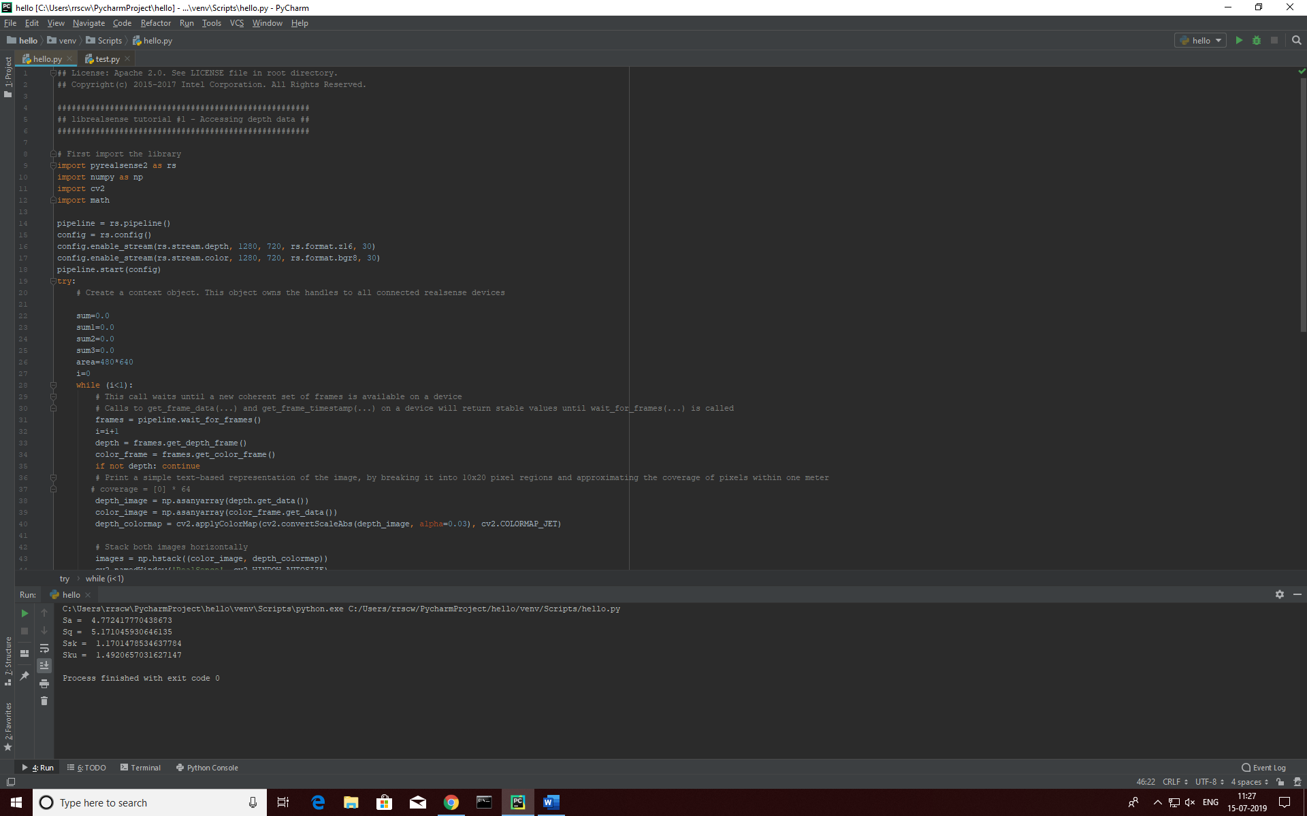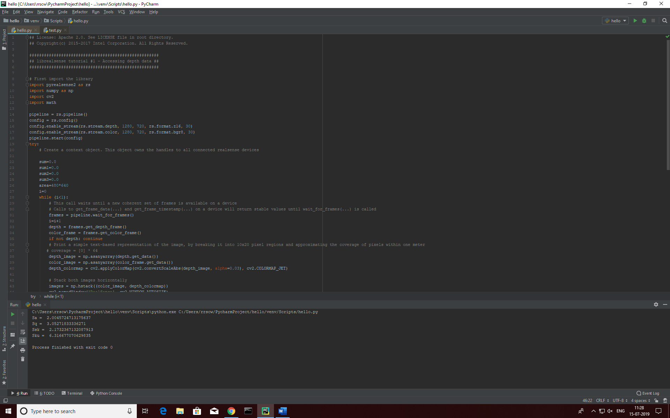

**5.Uses and Application**

* Measurement of Soil roughness
* Measuring Agricultural phenomena such as evaporation, inﬁltration or compression
* Dynamic characterization of soil microrelief
* Surface roughness parameters like average roughness, root mean square roughness, skewness and kurtosis.
* Correlation between different tillage conditions of soil
* Determining soil morphology
* Determining parameters such as aggregate stability, inﬁltration, runoff, water stored in depressions, erosion, heat ﬂux and evaporation
* Soil conservation
* Affecting germination and growth of seeds, plants and eventually inﬂuencing their fertility and productivity
* Monitoring cloddiness and roughness variations for the equipping of farm machinery for tillage

**Further Application in the future:**

* If we use this same concept on a very big scale and with the help of the appropriate technology, we can detect the surface of faraway planets and determine there geography there surface roughness, etc.
* With the help of ”Raspberry pi” or a similar devices like “Arduino”, etc. we can mount it up on a rover or an exploration vehicle with the help of which we can determine the physical features of places where we can’t go or is too dangerous for humans to go.

**6.Challenges Faced**

* In understanding the functions and features of Intel real sense SDK because it has so many features available for the user.
* During programming we have process every pixel of the image to calculate the roughness index is a big challenge for us.
* One the major challenge is to include the supported version of real sense library because most the version is not supporting in python.

**7.Conclusion**

This paper introduces an evaluation method for implementation of soil roughness index using inexpensive INTEL REAL SENSE RGB-depth camera imaging equipment. The acquired data is accurate and the operation is simple. In the present paper, the possible use of a INTEL REAL SENSE RGB-depth camera is proposed as a cost effective solution for three-dimensional characterization of soil microrelief and determining different soil roughness parameter . Tests on reference surfaces demonstrated how the sensor could give repeatable roughness characterization on surfaces.

**8.Refrences**

Aguilar, M. A., Aguilar, F. J., & Negreiros, J. (2009). Off-the-shelf laser scanning and close-range digital photogrammetry for measuring agricultural soils microrelief. Biosystems Engineering, 103(4), 504–517.

Bertuzzi, P., Caussignac, J. M., Stengel, P., Morel, G., Lorendeau, J. Y., & Pelloux, G. (1990). An automated, noncontact laser proﬁle meter for measuring soil roughness in situ. Soil Science, 149(3), 125–184.

Chatzinikos, A., Gemtos, T.A., & Fountas, S. (2013). The use of a laser scanner for measuring crop properties in three different crops in Central Greece. In J.V. Stafford (Ed.), Precision Agriculture’13: Proceedings of the 9th European Conference on Precision Agriculture pp. 129–136. The Netherlands: Wageningen Academic Publishers.

Che ´ne ´, Y., Rousseau, D., Lucidarme, P., Bertheloot, J., Cafﬁer, V., Morel, P., et al. (2012). On the use of depth camera for 3D phenotyping of entire plants. Computers and Electronics in Agriculture, 82, 122–127.

Chimi-Chiadjeu, O., Le He ´garat-Mascle, S., Vannier, E., Taconet, O., & Dusse ´aux, R. (2014). Automatic clod detection and boundary estimation from Digital Elevation Model images using different approaches. Catena, 118, 73–83.

Soltani, A., Robertson, M. J., Torabi, B., Yousefi-Daz, M. & Sarparast, R. Modelling seedling emergence in chickpea as influenced by temperature and sowing depth. Agricultural & Forest Meteorology. 138, 156–167 (2006).

Kamkar, B., Ahmadi, M., Soltani, A. & Zeinali, E. Evaluating Non-Linear regression models to describe response of wheat emergence rate to temperature. Configuring Juniper Networks Netscreen & Ssg Firewalls 2, 53–57 (2008).

Kamphorst, E. C. et al. Predicting depressional storage from soil surface roughness. Soil Sci Soc am J 64, 1749–1758 (2000).